Asian American Political Behavior

YouJia Chen

GOVT650

Professor Natalie Jackson

December 13th, 2021

**Introduction**

The 2016 election awakened many communities in the United States on their political right of voting. One of the communities that became more politically involved and more vocal on their own rights and opinions are Asian American. More political campaigns encourage Asian Americans to register and get out to vote. Some even argue being politically active means patriotism. Another community that has been focused on during the 2016 election is naturalized citizens who were one of the targets for the republican party which portrayed them negatively. There was a belief of naturalized citizens came to the U.S. for better job opportunities, therefore, they do not care about the social issues or political news that is happening in the United States. Some even believed that many immigrants do not know they are required to register in order to vote. However, the truth is that many naturalized immigrants have lived in the U.S. for a long-times. They have studied American civics and history for citizenships tests, which means they have sound knowledge of the American political system and know their political rights. Although many studies focus on the political difference in racial and gender groups, there are few studies on naturalized immigrants as they are also part of the minority community. This study focuses on Asian Americans by using the survey dataset from National Asian American Survey (NAAS) Pre-Election Survey, 2016 by Inter-university Consortium for Political and Social Research to find the difference between Native-Born American and Foreign-Born Americans.

**Literature Review**

Many scholars have paid attention to political activities and participation for a while now. The United States has a long history of immigration. Many Asians and Latinos came to the United States in the early year for different reasons. Some for better education opportunities, some for-employment options, some fled to the U.S. because of their home country’s conflicts. Some of them had chosen the path to become U.S. citizens. However, becoming a U.S. citizen is not as easy as most people think. It required a minimum of 5 years living in the U.S. as a legal permanent resident (green card) or three years as an American spouse. The whole naturalization process requires approximately 7-10 years, getting longer. To become a U.S. citizen, immigrants are needed to learn American history, civic, and the efficiency of English. The assimilation process is supposed to make immigrants learn the American political system and encourage them to be more active and eventually to participate in political activities, such as calling representatives for their needs, joining the protests to advocate their passion, or registering as a voter and turn out the votes. Though most people would say immigrants, especially new immigrants, would be more politically active because they would want their needs to be considered by the governments, many studies have shown otherwise. Different factors lead immigrants to be less busy. Mainly, immigrants among all ethnicity, Asian Americans are considered as the least politically active community, compared to Latino and African Americans. In this literature review, I broke into different sections to reach nonnaturalized and naturalized citizens, pre-naturalized and post-naturalized political opinions and activities, and possible factors and reasons that may or may not make immigrants hesitate to be more politically involved.

1. *Why We Should Care About Immigrants At All In U.S. Political Spectrum*

The United States is famous for being a cultural melting pot because people come from different countries. Since the Immigration Act of 1965, the foreign-born population has grown each year (Ong & Nakanishi, n.d.) dramatically. In 1965, the foreign-born adult immigrant population doubled from less than 8.5 million in 1970 to over 17.5 million in 1990(Ong & Nakanishi, n.d.). According to the Immigration Policy institute (Jeanne Batalova et al., 2021), More than 44.9 million immigrants lived in the United States in 2019. Among these 44.9 million immigrants, 23.2 million immigrants are naturalized citizens who converted their nationality into American (Jeanne Batalova et al., 2021).

Though Mexican is considered one of the majority of immigrants in the U.S., they have the lowest rate of naturalization (Ong & Nakanishi, n.d.). “In 1994, 55 percent of adult Asians were not citizens in contrast to 44 percent of the Latinos, 5 percent African Americans, and 2 percent non-Hispanic whites” (Ong, Nakishi, p,). On the other hand, Asian Americans have a higher rate of naturalization but a lower rate of registration to vote(Lien et al., 2001; Ong & Nakanishi, n.d.). The findings match most people’s typical idea about Asian American political engagement rate.

Even though immigrants are the majority of U.S. citizens, they are often considered to have low political and civic engagement. For instance, Barreto argued that one of the stereotypes of foreign-born Latinos is that they are least “engaged, least recruited, and have the lowest level of civic skills” (Barreto, 2005, p.). However, compared to other naturalized citizen, Latino has a higher political engagement rate. Barreto found that “naturalized Latinos were 11.4 percent more likely to vote in 2002” and they are “are at higher rates than non-Latinos in nine out of the ten majority-minority districts in Southern California” (2005, p.). Moreover, he found that foreign-born Latinos are 10 percent more likely to cast a ballot than non-foreign-born Latinos. Though Asian Americans are the central naturalized citizens, they relatively have the lowest rate of vote registration (Ong & Nakanishi, n.d.). “In 1992, for example, in the Oakland-San Francisco region, 56 percent of all adult Asian Pacific American citizens were registered to vote compared to 86 percent of Non-Hispanic whites (Ong & Nakashini, n.d.)” Among Asian immigrants, Filipinos have the highest naturalization rates. Ong and Nakanishi explained that since the U.S. colonization had influenced the Philippines from 1978 to 1946, they are more familiar with English and American cultures.

1. *Theory Why Naturalized Citizen Supposed To Be Politically Active*

We learned from the previous section that immigrants are not exactly politically inactive like most people think. Some scholars have argued a fee possible reason we should assume immigrants, especially naturalized citizens, are more politically active.

Some believe that adult immigrants and refugees came from backgrounds where their home countries do not have a democratic system like the United States. Therefore, when they start to get exposed to U.S. politics, they are more likely to learn the basic structure of the U.S. government (Barreto, 2005; Ong & Nakanishi, n.d.; Wass et al., 2015). Ong and Natasha argue that “these immigrants must undergo a process of political acculturation beyond the rudimentary exposure to the basic structure of the U.S. government presented in adult citizenship classes” (p.). Wass et al. (2015) called this phenomenon an exposure model that allows immigrants to have increased political engagement and their time staying in a new country. One of the motivations behind this theory is that the more time you spend in a new environment, the better and more advanced the language skills you would have (Levin, 2013). That is why many people believe the longer an immigrant stays in the U.S., the better and more knowledge they would have about American politics and vinting system.

Some also argue that the newcomers might have pressure to assimilate to the new society by forcing themselves to adopt the new language, culture, and social norms (Wass et al., 2015). Another scholar argues that naturalized citizens “chose” to be American citizens. They believe learning the American political system and being politically engaged is the citizen duty (Levin, 2013; Wals, 2013). Moreover, young immigrants are being raised and educated in the United States, so American behaviors and values become their behaviors and matters. Therefore, the young immigrants are more likely to vote(Ong & Nakanishi, n.d.). To fulfill their new civic duty, some newly naturalized immigrants would try to assimilate American cultures and learn American political culture and structure as much as they could.

Moreover, some people even argue that when individuals were politically active or had some form of political and civic engagement, they are more likely to be politically active in a new country as an immigrant(Ong & Nakanishi, n.d.; Pantoja et al., 2001; Wass et al., 2015). Wass et al. argue that the “past political activity may constitute an additional obstacle as a person migrating into a new environment may have to first “unlearn” the participatory patterns adopted in the previous context” (p.). Levin also argues that it is possible that they would believe being politically active in a new country isn’t the best idea because he found that 48% of immigrants reported that they voted before coming to the United States. He also found that 13% of immigrants reported “being active in a political party, political organization, or another type of organization before immigration,” meanwhile 29% and 11% of immigrants in similar home-country activities among naturalized respondents(2013). Pantoja et al. (2001) found that majority of immigrants who identified having a political identity and political involvement are more likely to identify themselves as politically active when they in the U.S. Therefore, the people who are already familiar with democratic process of voting are more likely continuing to be engaged political activities since they were already interested in politics.

1. *Naturalized Vs. Non-Naturalized Citizen Comparison*

Many studies have different results on political activities and level of political engagement of naturalized immigrants and native-born immigrants (who are second-generation of naturalized immigrants).

First of all, some argue that naturalization has a negative impact on civic engagement. Many studies showed the voter registration rate among immigrants are low(Barreto, 2005; Hayduk, 2004; Ong & Nakanishi, n.d.). Among all naturalized citizens, the odds of voting are 26 percent lower than the native-born U.S. citizen (Barreto, 2005). In Barreto’s study, he found that in regressions for all Latinos American citizens, naturalized Latinos’ likelihood to register and to vote is less than native-born Latino. (Barreto, 2005). Similarly, Ong and Nakanishi found that majority of naturalized Asian immigrants have lower rates of voter registration than the native born citizens. (Ong & Nakanishi, n.d.)

A naturalized citizen, however, has a significantly high voters turnout rate. Particularly, the naturalized Latino voters turnout rate is considered high (Barreto, 2005; Wals, 2013). For instance, In 2002 Southern California, 39 percent of Latinos voted compared to 47.4 percent of non-Latinos in the 2002 election for Governor(Barreto, 2005). For Asian Americans, both Asian Pacific American naturalized and native-born voters had among the highest rates of voting (Ong & Nakanishi, n.d.). Even though most naturalized citizens do not have a high political engagement rate such as registering to vote or calling representatives, they still have a high voter turnout rate which is a good sign of a more American political environment.

1. *Motives And Causation to Make Immigrants More Political Active*

There are some findings of what could potentially be the factors that motivate or cause naturalized immigrants to be more politically active. The most common finding is the duration in U.S.(Levin, 2013; Ong & Nakanishi, n.d.; Wass et al., 2015). Many scholars found that the earlier immigrants who moved to the U.S. and stayed in the countries more than 10 years are more likely to register to vote and go vote. Ong and Nakanishi found that “Asian Pacific naturalized citizens who immigrated within the past twenty years have rates of registration that are substantially lower than native-born citizens and naturalized citizens who arrived before 1975” (Ong & Nakanishi, n.d.). However, Wass et al, had a different result of findings. They found that “immigrating at an older age are more inclined to vote”. These studies contradict each other, it is hard to say if the year of duration matters or if it’s the age of naturalized citizen’s matter.

Similar to the duration of political exposures of the host country. Wass et al. believed that having children or family members to take care of also will increase the chances of the vote because they would have to interact with school officials and be more concerned about public policies related to their family’s benefits (Wass et al., 2015). They believe these two possibilities imply social inclusion, to give them more exposure to a new country’s politics and policy system. Another explanation of exposure of politics is important is from forced volunteerism. Levin believed the young immigrant who is forced to do volunteer through school programs might have a better opportunity to learn civic engagement and the political system in the U.S. (Levin, 2013). From their experience, they would learn the duty as citizens and understand voting is part of the method to advocate their political voice.

The probability that makes naturalized citizens less politically engaged could be the language barrier (Barreto, 2005; Levin, 2013; Lien, 1994; Ong & Nakanishi, n.d.). Ong and Nakanishi believed for Asian Pacific American community to be so little political active are because of lack of bilingual voter registration application forms and ballots, and opposition to the implementation of legislation like the National Voter Registration Act of 1993, and it might have increased the challenge for fair and inclusive political practices and policies(Ong & Nakanishi, n.d.). Therefore, it might create the phenomenon of why young immigrants are more likely to be politically engaged than older naturalized immigrants since the younger generation can adopt a new language easier.

Moreover, the naturalized citizen might have a certain amount of exposure to the American political system (Barreto, 2005). Barreto pointed out in order to become familiar with U.S. political system, a naturalized citizen would need to “learn to fill out extensive paperwork; pass a basic course on civic responsibility; and finally, gain confidence, as new citizens, in the American political process”(2005). It is a really long process, which can take more than 10 years (Hayduk, 2004, p.504).

The place of birth also is one of the factors to make immigrants votes. Some studies found that native-born immigrants have a higher rate of voter registration than those who are foreign-born. For example, Ong and Nakanishi found 56 percent of all US-born Asian Americans were registered compared to 49 percent of those who were naturalized(Ong & Nakanishi, n.d.). Moreover, if they were politically active already prior to immigrant to a new country, they are more likely to be politically active (Ong & Nakanishi, n.d.; Pantoja et al., 2001; Wass et al., 2015). It might come down to where immigrants are moving are from, if they came from a country that has a similar political system and climate as the United States, they might be more likely to vote in the United States.

Based on the points above, the birth of place, year of duration in the United States, prior political interests, and experience and efficiency of English can be some factors to motivate immigrants to register to vote.

The theory based on the literature review is that talking about politics are the most reason that leads immigrant or second-generation immigrant to plan on voting. However,

1. Native-born citizens tend to register to vote more compared to foreign-born citizens.
2. Native-born citizens have a higher percentage on they are certain to vote and pretty likely to vote compared to Foreign-Born Citizens
3. Foreign-Born Asian Americans who planned to vote are the people who talk politics often.
4. Female Foreign-Born Asian Americans plan to vote more.
5. the longer the Naturalized American stay in the US, the more likely plan to vote

**Description Of the Data and Methods:**

This section is using the dataset from National Asian American Survey (NAAS) Pre-Election Survey, 2016 by Inter-university Consortium for Political and Social Research. 4,787 Asian American adults in the United States were questioned through telephone interviews for approximately 25 minutes. Survey interviews were conducted in eleven languages (English, Spanish, Cantonese, Mandarin, Korean, Vietnamese, Tagalog, Japanese, Hindi, Hmong, Cambodian) based on the interviewee's preference.

This study chose a pre-election survey instead of the post-election survey because many people believe after the 2016 election, many communities have a significant change in their political behavior. Therefore, focusing on pre-election, it can see what was the political pattern of the Asian Americans. All variables in this dataset are categorical variables, therefore, the dataset was analyzed by the statistical methods that are used for categorical variables, such as crosstab, logistic regression, Pearson’s chi-squared test, Fisher Exact test, and Cochran-Mantel-Haenszel.

After some data organization, there are 2621 values (participants) in this dataset. The youngest person is 23 years old, and the oldest person in this dataset is 102 years old. the average is 62 years old. 1294 Females and 1290 Males in the dataset. The survey included sizable samples of Asian Americans in 9 Asian national origin groups (Chinese, Filipino, Indian, Vietnamese, Korean, Japanese, Hmong, Cambodian), as well as Native Hawaiian/Pacific Islanders.

In this section, Native-Born citizens refer to Asian Americans who were born in the United States, including Hawaii. Foreign-Born citizens refer to Asian Americans born in another country other than the United States, they could be either child of American or Naturalized citizens.

**Statistical Analysis**

*[CrossTable are at the end of the paper]*

Hypothesis 1: Native-born citizens tend to register to vote more compared to foreign-born citizens.

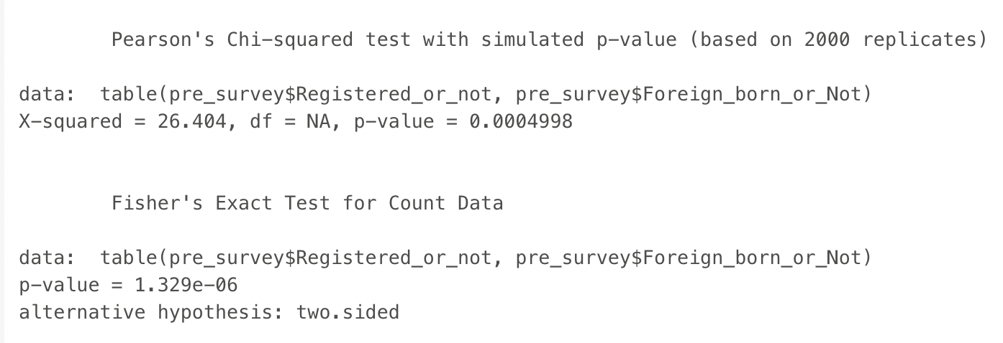We have a chi-squared value of 26.40. Since we get a p-value < 0.0049, we reject the null hypothesis and conclude that the two variables are in fact dependent. Same result for using fisher test.

Although native-born Asian American has a higher percentage of registering to vote with 89%, foreign-born Asian American also has 82% who has registered to vote. There is only a slight difference in percentage for registering to vote.

Hypothesis 2: Native-born citizens have a higher percentage on they are certain to vote and pretty likely to vote compared to Foreign-Born Citizens

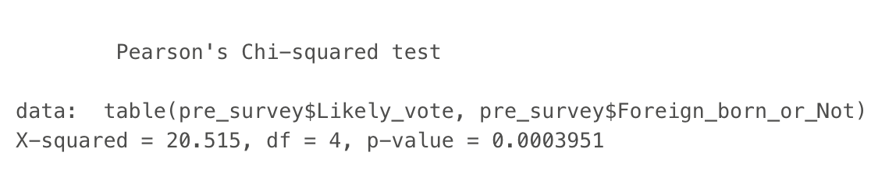We have a chi-squared value of 20.515. Since we get a p-value < 0.0039, we reject the null hypothesis and conclude that the two variables are in fact dependent.

From the cross-tab analysis, we learned that Native-born Asian American has a higher percentage on both “I am pretty likely to vote”. Native-Born Americans believed “I am absolutely certain I will vote” (68%) and “I am pretty likely to vote” (12%). They are also 9.1% 50-50 to vote, 3.5% less than 50-50 to vote. However, 58% of foreign-born Asian Americans are “I am absolutely certain I will vote” and 7.8% of foreign-born Asian Americans are “pretty likely to vote”, and 3.8% are less than 50-50 to vote.

Interestingly, foreign-born Asian American has a higher percentage on “I will not vote this year” with 10% of samples, in comparison, Native-born Asian American only has 7.2%.

Hypothese3: Foreign-Born Asian Americans who planned to vote are the people who talk politics often.

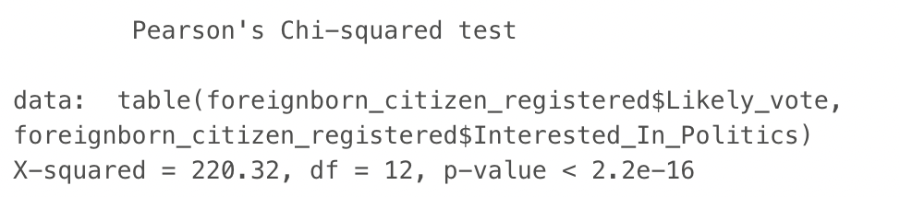According to the chi-square test, the x-squared is 220.32, and p-value <2.2e-16. It means both are likely to vote and are interested in politics.

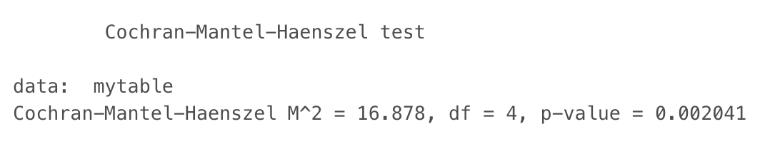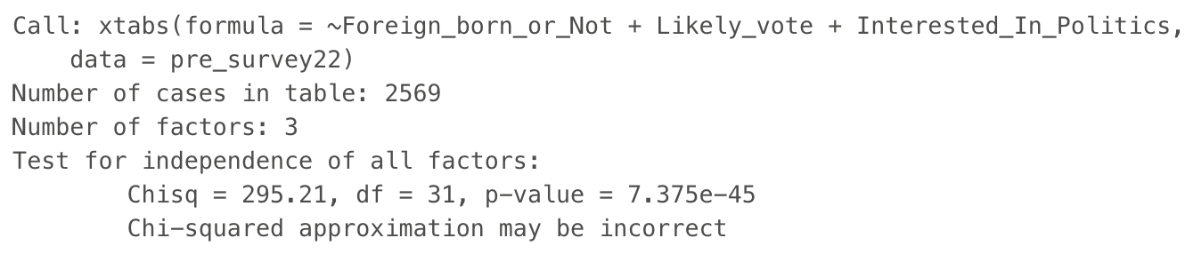Since using chi-squared for crosstabulations table might not be appropriate, so I used the Cochran-Mantel-Haenszel test instead, and the p-value <0.002. Therefore, we know it is statistically dependent on these three variables.

Foreign-born citizens who certainly will vote and likely will vote all have “somewhat” interest as the highest with a 32% and 46% for later. Interestingly, none of these two groups are very interested in politics. For the group certain will vote, they only have a 29% of people who are very interested in politics, it is close the people who are interested in politics with a 28% Also, another interesting finding is that people who decided they will not vote in 2016, has 32% for somewhat interested in politics, it is the similar percentage for not at all interested with a 37%.

Hypothese4: Female Foreign-Born Asian Americans plan to vote more.

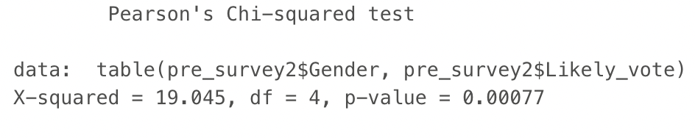

The x-square = 10.366 and p<0.0007 on Foreign-Born Gender and likely to vote. Gender and the decision on likely to vote are statistically dependent.

From the crosstab, it seems males actually plan to vote more 69.2% of them are mostly to vote (60% absolutely will vote and 9.2% pretty likely to vote), and only 76.9% of females are mostly to vote (69% absolutely and 7.9% pretty likely to vote). More interestingly, for people who decided not to vote, females (14%) have a higher percentage than males (8.6).

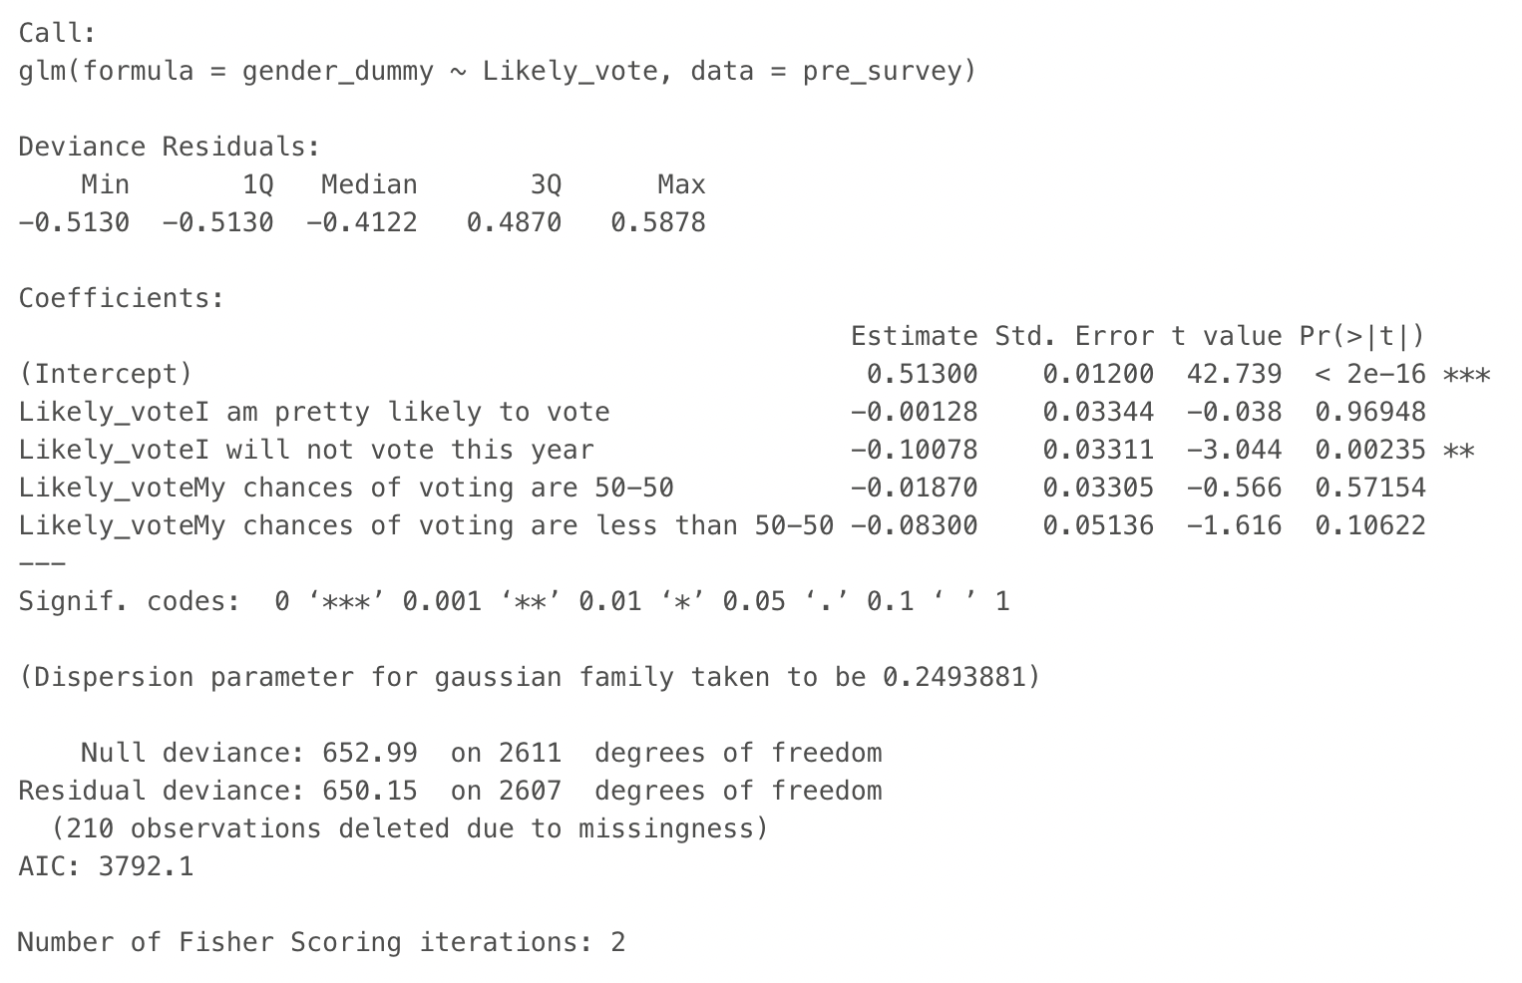

Using logistic regression on gender and likely to vote.

logit(p) = 0.513 + (- 0.001) * pretty likely vote + (- 0.100) * will not vote + (-0.018)* 50-50 chances to vote + (- 0.083)*are less than 50-50 to vote

Hypothesis 5: the longer the Naturalized American stay in the US, the more likely plan to vote

Mean and Standard Deviation for year arrival for naturalized citizens on the plan on voting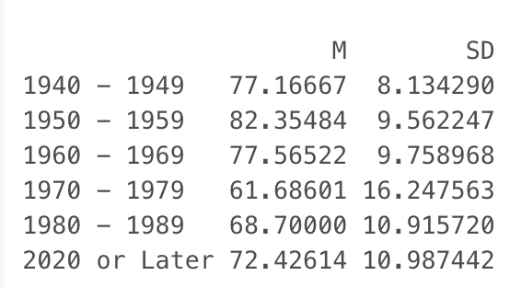. The average for 1940 – 1949 are 77 years old.

Based on the chi-square, we got an X^2 43.358 and a p-value of 0.003. Since we got a p-value smaller than 0.05, we can reject the null hypotheses of they are not statistically independent and conclude that they are dependent on each other.

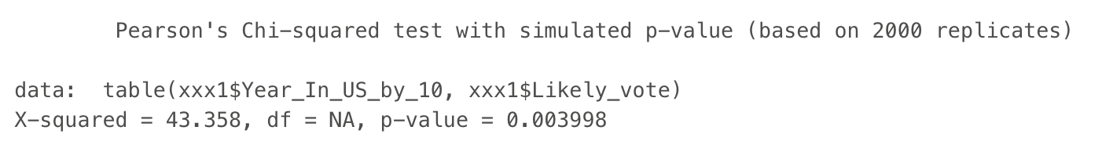

We learned from the cross-tab that 62% of people who “absolutely certain will vote” came from 1970-1979, and 24% came from 2020 or later. People who were “pretty likely to vote” 72% came in 1970-1970. Such a high percentage is because of the limited sample size for other people who arrived in a different year. 66% of foreign-born citizens arrived between 1970-1979, and 20% arrived in 2020 or later, 6.9% are from 1980 -1989, 5.3% are from 1960 -1969, 1.7% are from 1950 -1959.

**Limitation:**

There are a few limitations to this dataset. First, the majority of the immigrant arrived between 1970 to 1979, it was hard to examine the relationship between their decision on voting with the year of arrival. Second, there are many missing values which makes it difficult to determine the legitimacy of the statistic tests.

**Discussion/Conclusion:**

There is no huge difference in registering to vote for Native-Born or Foreign-Born Asian Americans. It seems the majority of Asian Americans are registered to vote, including foreign-born citizens (some are naturalized citizens). This overrides the argument of immigrants do not know the voting system in the United States. In fact, they have a high-rate percentage or are registered to vote. This aligns with the Barreto points on they were obligated to learn American voting system for long period of time.

In 2016, many politicians argue foreign-born citizens do not care about American politics and many believe they have low voting registered rate; however, the finding proves the argument is not true. Furthermore, there is only a slight difference in the plan to vote: more native-born Americans planned to vote than foreign-born Americans. This result breaks the assumption of foreign-born citizens cares less about elections in the United States.

Although foreign-born citizens have 65.8% are pretty likely to vote and certain will vote, most of them are only somewhat interested in politics. People who are not planning to vote are also interested in politics. One of the possible reasons is that they are not satisfied with both parties’ presidential candidates. For that reason, whether they are interested in politics or not, they are registered to vote, yet they do not want to vote on either candidate. Therefore, it seems interests in politics do not have any strong association with the decision on voting for Asian Americans.

In terms of gender, it seems that male Asian Americans plan on voting more than female Asian Americans. It is interesting because, in 2016, one of the presidential candidates is female. It shows that the gender of the presidential candidates does not interest Asian Americans. Another possible explanation is that the cultural background of Asians. It was believed that females should not be interested in politics because they should only focus on their family and spouse’s family, instead of the society. However, men should care about politics because they are responsible for the external matter of the house. The last finding in this study is that the year of arrival does not have enough sample size to see if it has any association with the voting decision. Since most foreign-born citizens came in 1970-1979, there is a bias mean of comparison on all groups of arrivals. Since the limited sample of size, it failed to testify to Ong and Nakanishi’s finding on “Asian Pacific naturalized citizens stayed in the United States more than twenty years have rates of registration.

Overall, this study found Native and Foreign-Born citizens have a similar pattern on registering to vote and the decision on likely to vote. Therefore, the birth place do not make a person more or less politically active.

**Reference**

Barreto, M. A. (2005). Latino Immigrants at the Polls: Foreign-born Voter Turnout in the 2002 Election. *Political Research Quarterly*, *58*(1), 79–86. https://doi.org/10.1177/106591290505800107

Hayduk, R. (2004). Democracy for all: Restoring immigrant voting rights in the US. *New Political Science*, *26*(4), 499–523. https://doi.org/10.1080/0739314042000297478

Jeanne Batalova, Hanna, M., & Levesque, C. (2021, February 11). Frequently Requested Statistics on Immigrants and Immigration in the United States. *Migration Policy Institute*. https://www.migrationpolicy.org/article/frequently-requested-statistics-immigrants-and-immigration-united-states?gclid=Cj0KCQjwlOmLBhCHARIsAGiJg7lXsVuh8M1RHtA9EGhJRKcC_eDTPMIV9Q6U0dQMy2kkQmdetIVGA2oaAjNiEALw_wcB

Levin, I. (2013). Political Inclusion of Latino Immigrants: Becoming a Citizen and Political Participation. *American Politics Research*, *41*(4), 535–568. https://doi.org/10.1177/1532673X12461438

Lien, P. (1994). Ethnicity and political participation: A comparison between Asian and Mexican Americans. *Political Behavior*, *16*(2), 237–264. https://doi.org/10.1007/BF01498879

Lien, P., Collet, C., Wong, J., & Ramakrishnan, S. K. (2001). Asian Pacific-American Public Opinion and Political Participation. *Political Science & Politics*, *34*(03), 625–630. https://doi.org/10.1017/S1049096501000981

Ong, P., & Nakanishi, D. (n.d.). Becoming Citizens, Becoming Voters: The Naturalization and Political Participation Of Asian Pacific Immigrants. *University of California, Los Angeles*.

Pantoja, A. D., Ramirez, R., & Segura, G. M. (2001). Citizens by Choice, Voters by Necessity: Patterns in Political Mobilization by Naturalized Latinos. *Political Research Quarterly*, *54*(4), 729–750. https://doi.org/10.1177/106591290105400403

Wals, S. C. (2013). Made in the USA? Immigrants’ imported ideology and political engagement. *Electoral Studies*, *32*(4), 756–767. https://doi.org/10.1016/j.electstud.2013.05.032

Wass, H., Blais, A., Morin-Chassé, A., & Weide, M. (2015). Engaging Immigrants? Examining the Correlates of Electoral Participation among Voters with Migration Backgrounds. *Journal of Elections, Public Opinion and Parties*, *25*(4), 407–424. https://doi.org/10.1080/17457289.2015.1023203

**Appendix**

*1. Cross-table for Native/Foreign Born Citizen and Whether They Registered to Vote*

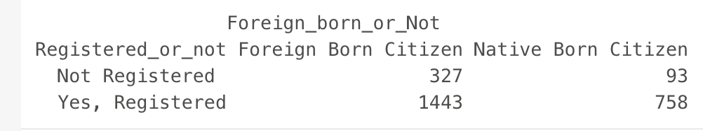

*2. 1. Cross-table for Native/Foreign Born Citizen and How Likely They will Vote*

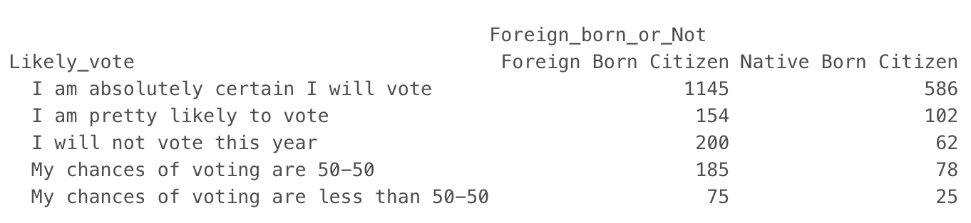

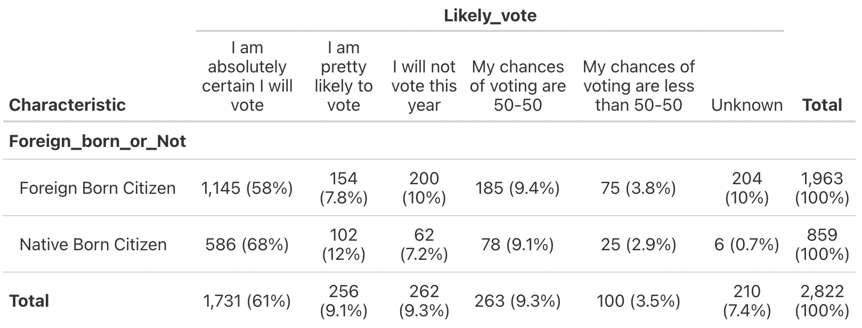

3. *Cross-table for How Foreign Born Citizens Interested in Politics and How Likely They will Vote*

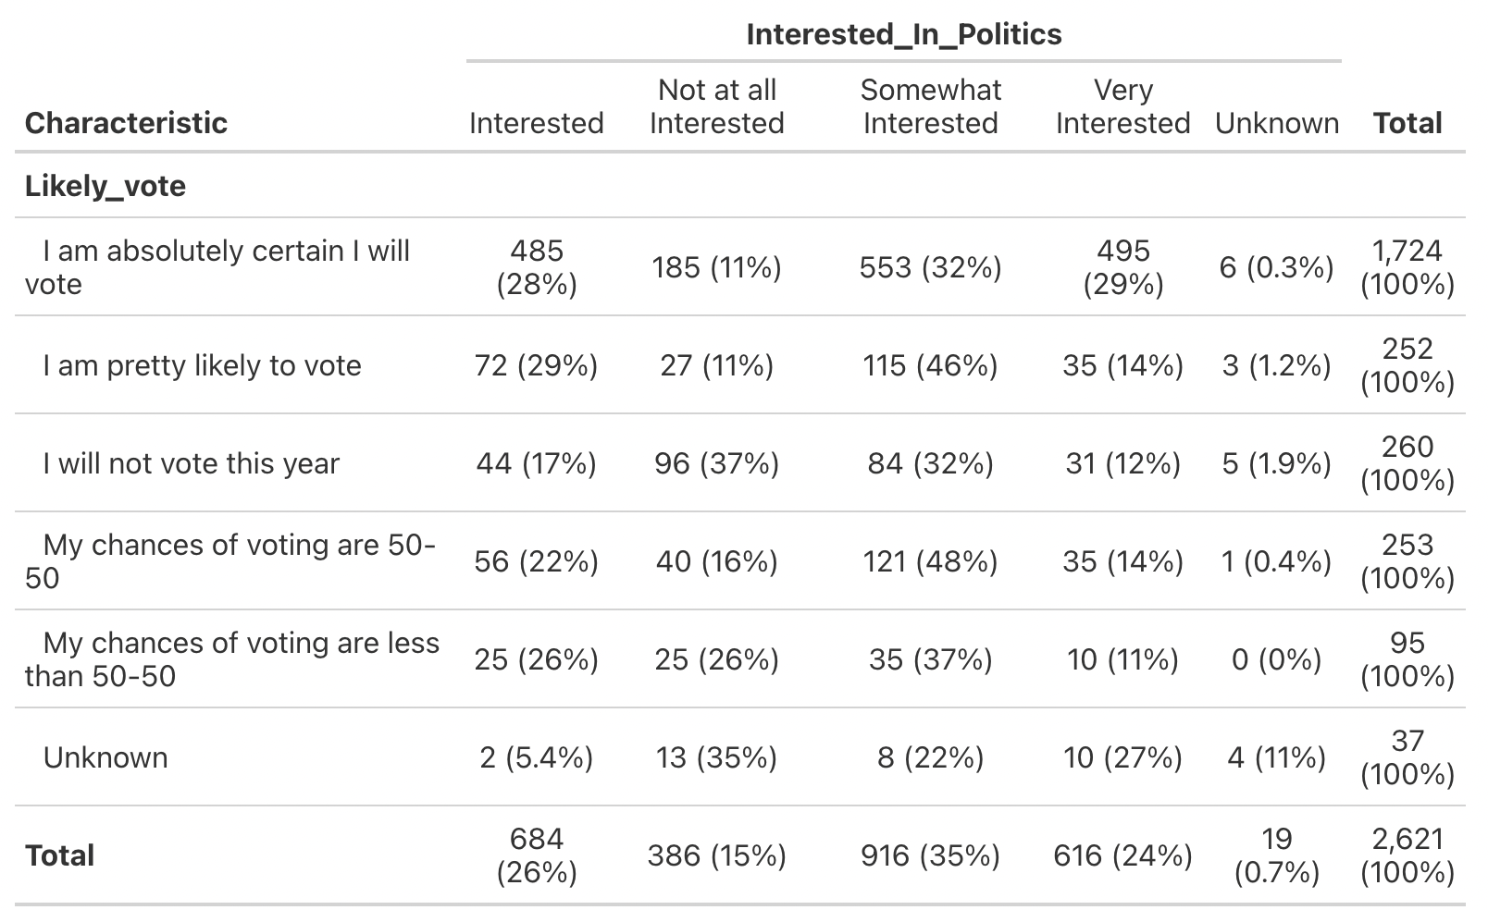

*4. Cross-table for Foreign Born Citizens Gender and How Likely They will Vote*

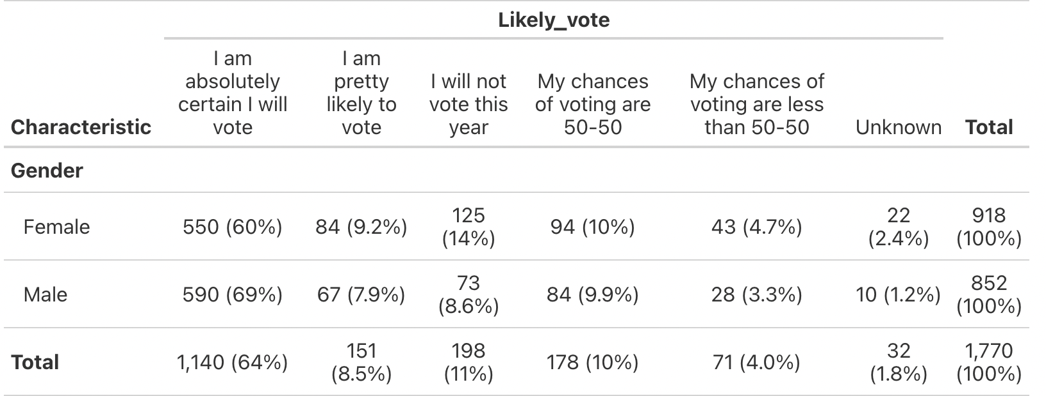

5. *Cross-table for Year of Arrival for Foreign Born and How Likely They will Vote*

